KARA – community volunteers working on behalf of
Kleinburg, Nashville, Purpleville & Area residents

Sketch Map of Kleinburg and Area

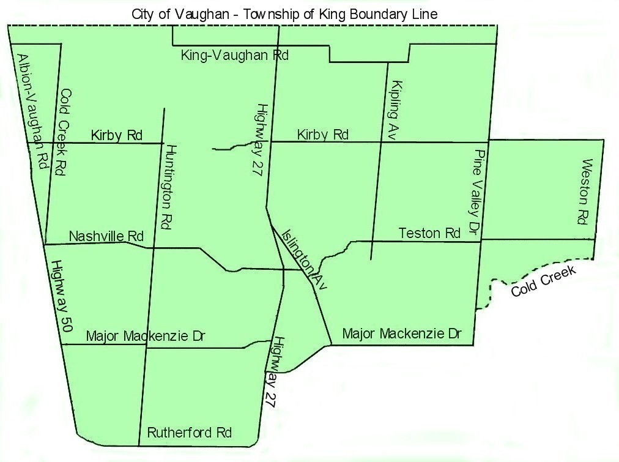

The coloured portion of this map is a reasonable representation of the neighbourhood encompassed by Kleinburg and Area. For the precise definition of Kleinburg and Area, please read the extract from the Association’s constitution below.

Extract from the constitution of Kleinburg and Area Ratepayers’ Association – ‘Kleinburg and Area is that land enclosed by a line drawn eastward on the northern boundary of the City of Vaughan, to and then southward on the centreline of Pine Valley Drive, to and then eastward on the centreline of Kirby Road, to and then southward on the centreline of Weston Road, to and then westward on the centreline of the watercourse (sometimes known as Cold Creek) that flows generally westward (entirely south of Teston Road and entirely north of Major Mackenzie Drive, and being joined by tributaries in this portion of its course), to and then southward on the centreline of Pine Valley Drive, to and then westward on the centreline of Major Mackenzie Drive, to and then southward on the centreline of Regional Road 27, to and then westward on the centreline of Rutherford Road, to and then northward on the western boundary of the City of Vaughan, to the northern boundary of the City of Vaughan and the line’s point of origin.’

09/11/11AB

